UNIT 4 : TREE

Title: Develop an Arithmetic Calculator Using an Expression Tree from a Postfix Expression.

Aim :

To develop an arithmetic calculator using a binary expression tree that constructs a tree from a postfix expression, displays inorder, preorder, and postorder traversals, and evaluates the expression.

Problem Statement :

Develop a C++ program to construct a binary expression tree from a given postfix expression. The program should display the inorder, preorder, and postorder traversals of the tree and calculate the final result of the arithmetic expression using the expression tree.

Objectives :

- To understand the concept of a binary expression tree.
- To construct an expression tree using a postfix expression.
- To perform inorder, preorder, and postorder traversals.
- To evaluate an arithmetic expression using a binary tree.
- To understand the use of stacks in tree construction.

Theory :

An expression tree is a binary tree used to represent arithmetic expressions.

In an expression tree:

- Leaf nodes represent operands, such as numbers.
- Internal nodes represent operators, such as +, -, *, and /.
- A stack is used to construct the tree from a postfix expression.

Types of traversals:

- Inorder Traversal: Visits the left subtree, root node, and right subtree.
- Preorder Traversal: Visits the root node, left subtree, and right subtree.
- Postorder Traversal: Visits the left subtree, right subtree, and root node.

The expression tree can also be evaluated to calculate the final arithmetic result.

Algorithms :

Step 1: Start the program.

Step 2: Accept a postfix expression from the user.

Step 3: Read the expression from left to right.

Step 4: If the character is an operand, create a node and push it onto the stack.

Step 5: If the character is an operator:

- Create a new node for the operator.
- Pop two nodes from the stack.
- Assign the first popped node as the right child.
- Assign the second popped node as the left child.
- Push the operator node back onto the stack.

Step 6: Repeat until the entire postfix expression is processed.

Step 7: The remaining node on the stack becomes the root of the expression tree.

Step 8: Display the inorder, preorder, and postorder traversals.

Step 9: Evaluate the expression tree to calculate the result.

Step 10: Display the final result.

Step 11: Stop the program.

Flowchart :
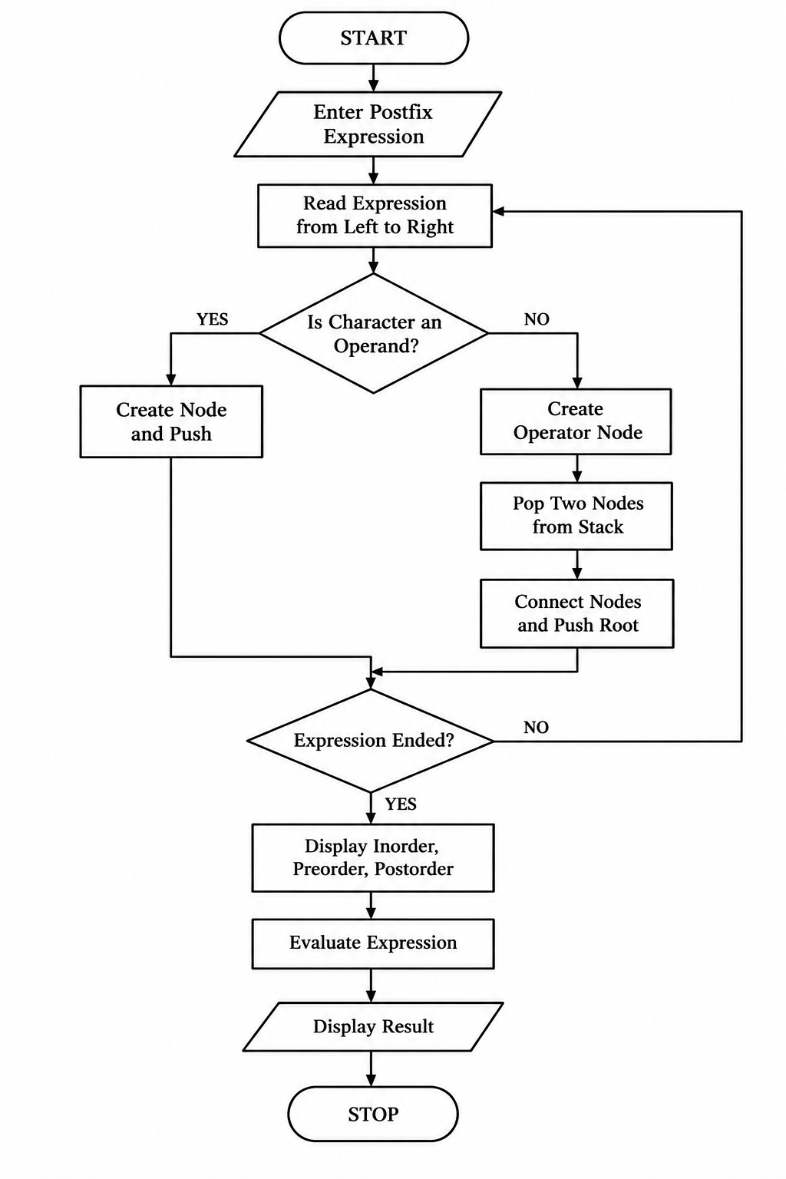

Program :

#include <iostream>
#include <stack>
#include <string>
#include <cctype>
using namespace std;

struct Node
{
char data;
Node *left;
Node *right;
};

Node* createNode(char value)
{
Node* newNode = new Node;
newNode->data = value;
newNode->left = NULL;
newNode->right = NULL;
return newNode;
}

Node* buildTree(string postfix)
{
stack<Node*> s;
int i;
char ch;

for (i = 0; i < postfix.length(); i++)
{
ch = postfix[i];

if (isalnum(ch))
{
s.push(createNode(ch));
}
else
{
if (s.size() < 2)
{
cout << "Invalid postfix expression!";
return NULL;
}

Node* newNode = createNode(ch);

newNode->right = s.top();
s.pop();

newNode->left = s.top();
s.pop();

s.push(newNode);
}
}

if (s.size() != 1)
{
cout << "Invalid postfix expression!";
return NULL;
}

return s.top();
}

void inorder(Node* root)
{
if (root != NULL)
{
if (root->left != NULL)
cout << "(";

inorder(root->left);
cout << root->data;
inorder(root->right);

if (root->right != NULL)
cout << ")";
}
}

void preorder(Node* root)
{
if (root != NULL)
{
cout << root->data << " ";
preorder(root->left);
preorder(root->right);
}
}

void postorder(Node* root)
{
if (root != NULL)
{
postorder(root->left);
postorder(root->right);
cout << root->data << " ";
}
}

int evaluate(Node* root)
{
int leftValue, rightValue;

if (root->left == NULL && root->right == NULL)
return root->data - '0';

leftValue = evaluate(root->left);
rightValue = evaluate(root->right);

switch (root->data)
{
case '+':
return leftValue + rightValue;

case '-':
return leftValue - rightValue;

case '*':
return leftValue * rightValue;

case '/':
if (rightValue == 0)
{
cout << "\nError: Division by zero!";
return 0;
}
return leftValue / rightValue;

default:
return 0;
}
}

int main()
{
string postfix;
Node* root;

cout << "Enter postfix expression: ";
cin >> postfix;

root = buildTree(postfix);

if (root == NULL)
{
cout << endl;
return 0;
}

cout << "\nInorder Traversal: ";
inorder(root);

cout << "\nPreorder Traversal: ";
preorder(root);

cout << "\nPostorder Traversal: ";
postorder(root);

cout << "\nEvaluated Result: ";

cout << evaluate(root) << endl;

return 0;
}

Output :

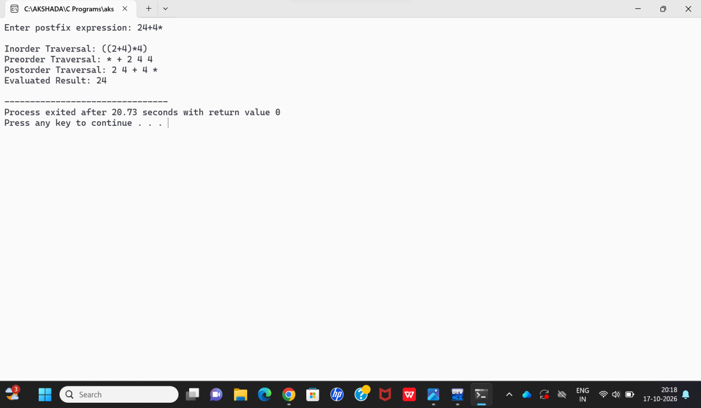

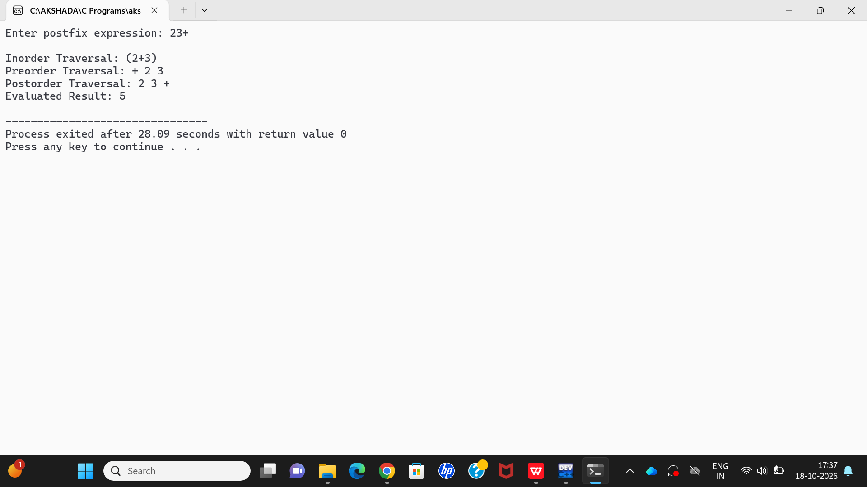

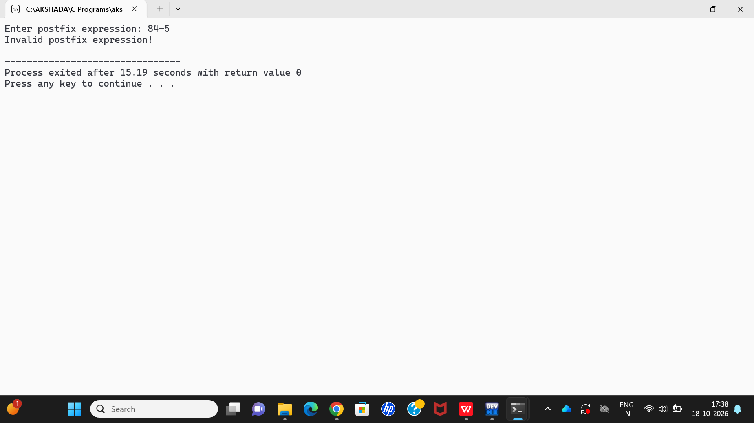

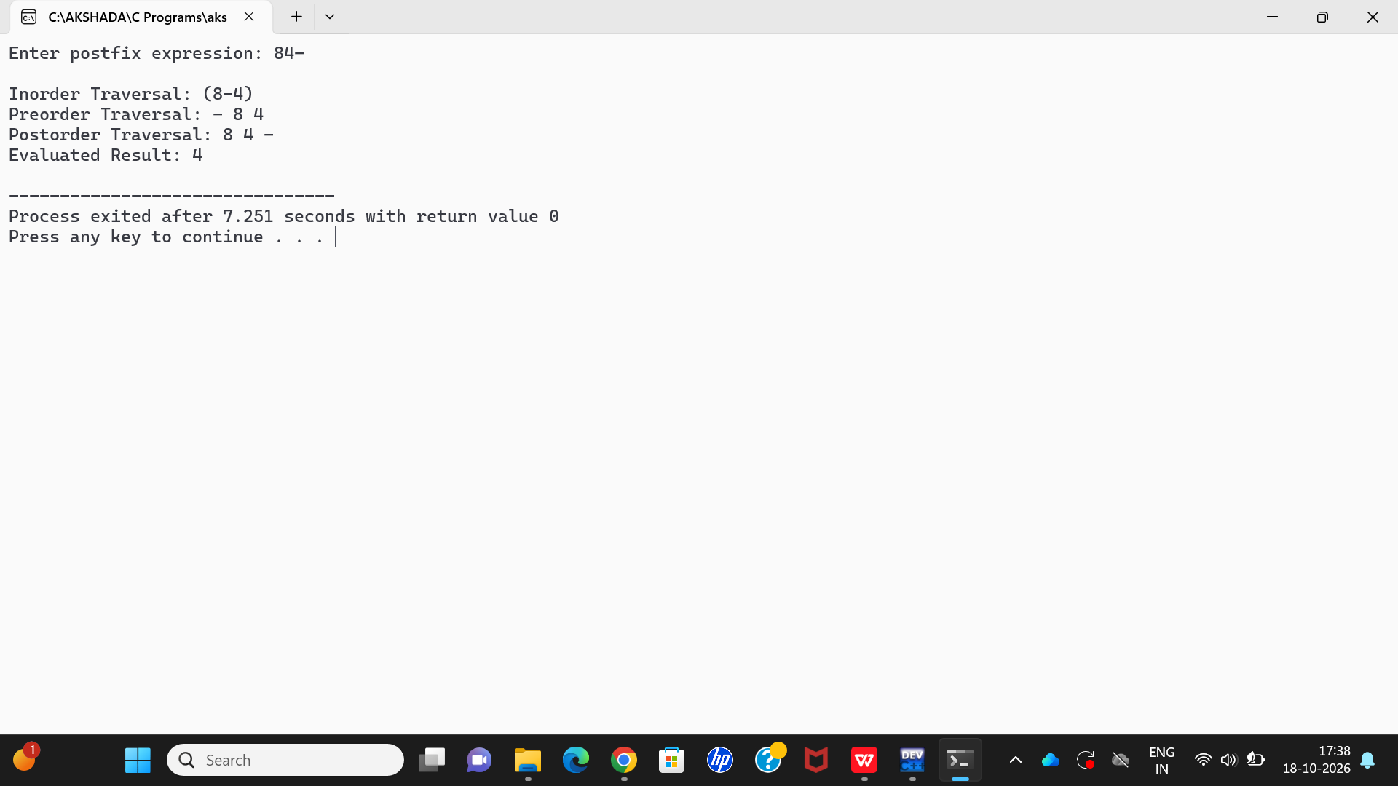

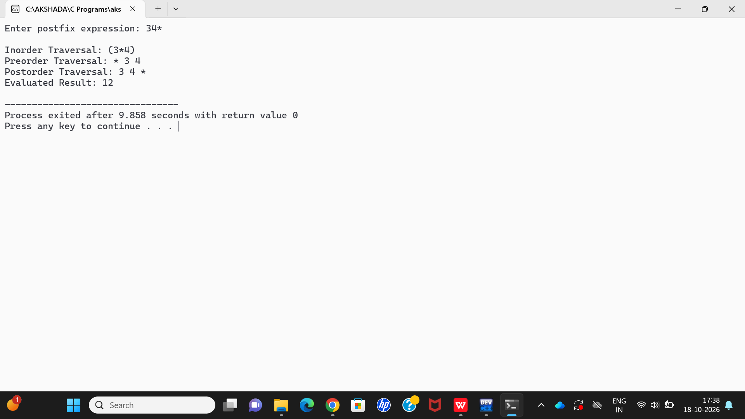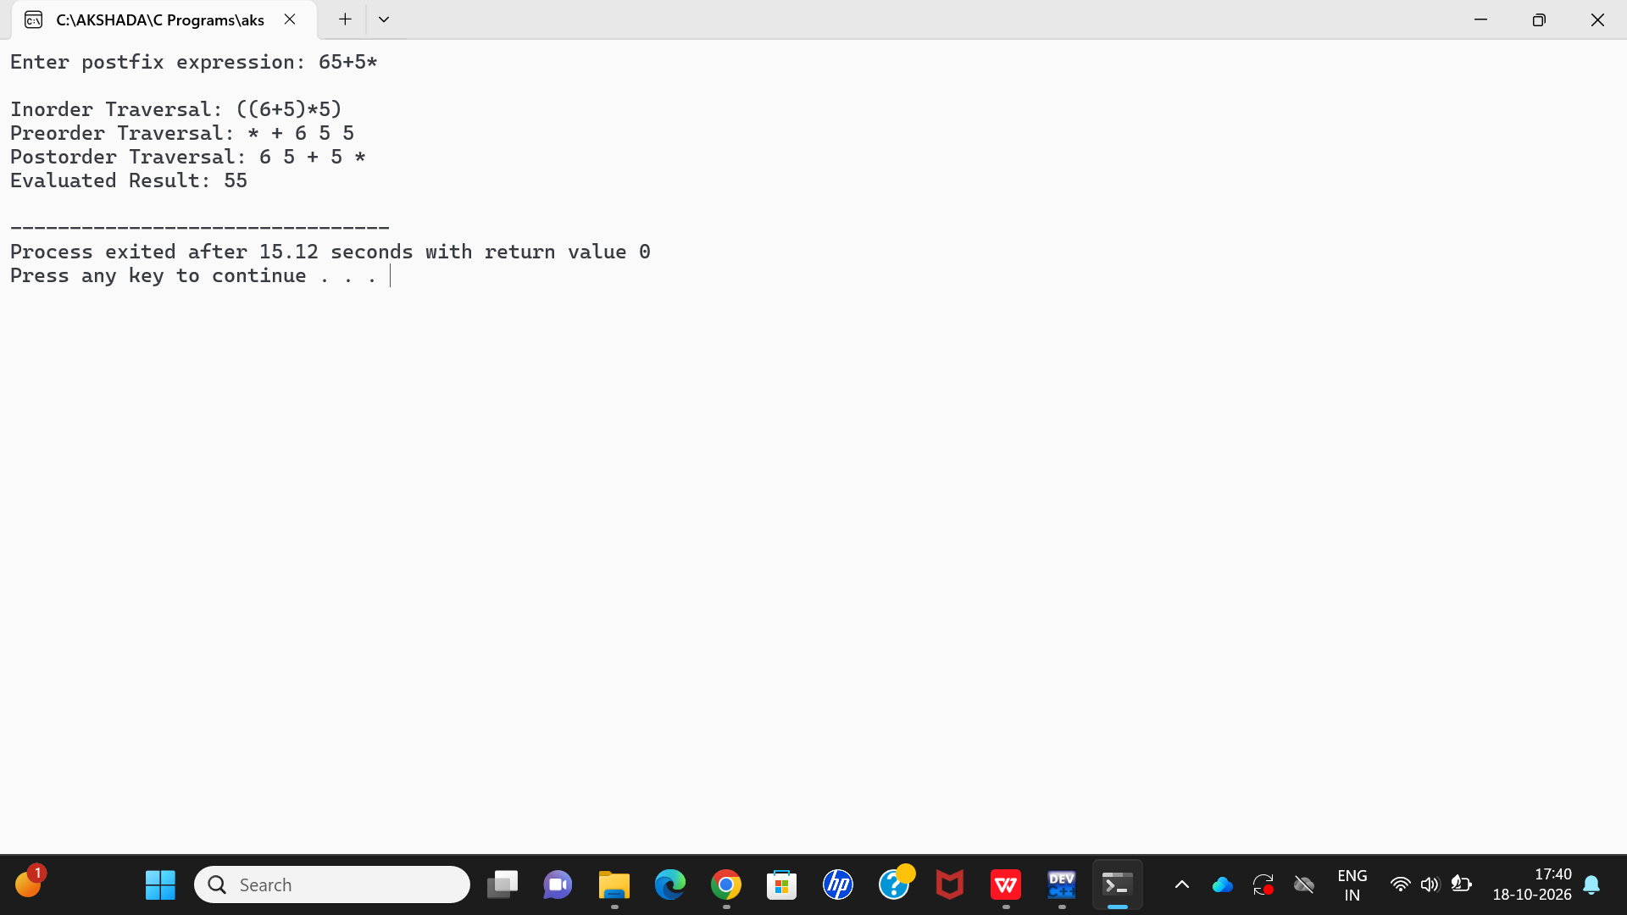

Applications :

- Used in arithmetic expression evaluation.
- Used in compilers to process mathematical expressions.
- Used in calculators and mathematical software.
- Helps understand binary trees and stack operations.
- Used in expression parsing and syntax analysis.

Conclusion :

The arithmetic calculator was successfully developed using C++ and a binary expression tree. It constructs a tree from a postfix expression, displays inorder, preorder, and postorder traversals, and evaluates the expression to obtain the final result. This program helps us understand binary trees, stack operations, and expression evaluation.

